CHESS CASTLE CAMP AND WORKSHOP
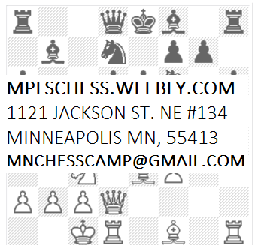
Directed By: The Official Camp of the Chess Castle of Minnesota, the most active, serious, and largest chess club in Minnesota
What we offer:
- Chess instruction adapted for each student’s individual needs.
- Different levels of instruction taught by several strong chess instructors.
- Supervised recreational activities at Logan Park such as the playground, frisbee and soccer.
- Lunches are provided daily.
Who is this for?
This camp is designed for those who have a desire to learn and improve their chess skills. Campers will be placed in different groups based on playing ability and age. The instructors for this camp have coached and led teams to State and National victories. Registration is open for kids aged 5 to 18.
June 20-23(9 am-4 pm), July 4-7 (9am - 4pm) August 1-4 (9 am-4 pm)
